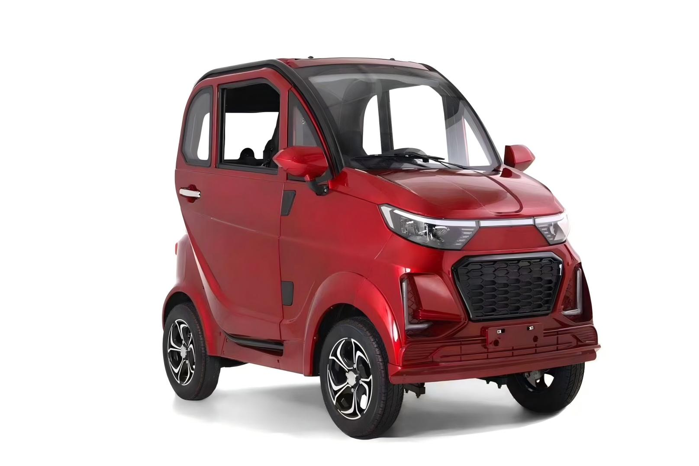

SCOOTER PER DISABILI



EV5

INDEX

Product introduction .................................................................................................................................... Page 1

Intended use .................................................................................................................................................... Page 1

EC conformity ....................................................................................................................................................Page2

General warnings ..............................................................................................................................................Page 3

Security ..................................................................................................................................................................Page4

Warnings for use ...............................................................................................................................................Page5-6

Before each use..................................................................................................................................................Page7

Weight restrictions ............................................................................................................................................Page7

Specifications .......................................................................................................................................................Page 8

Operation of the scooter ................................................................................................................................Page9

Driving and braking ............................................................................................................................................Page9

General functions handlebar model .............................................................................................................Page10-11

General functions steering wheel model .....................................................................................................Page12-18

Display .........................................................................................................................................................................Page 19

Charging the battery .............................................................................................................................................Page18

LED indicators ...........................................................................................................................................................Page20

Troubleshooting battery ........................................................................................................................................Page21

Attention .......................................................................................................................................................................Page22

Problem solving ..........................................................................................................................................................Page23-24

Manufacturer's label Page 25INTRODUCTION
Thank you for choosing the 4 wheel electric scooter. The electric scooters have been designed and manufactured to meet all your needs for practical, correct and safe use. This manual

contains small tips for the correct use of your chosen device and valuable tips for

Your safety. We recommend that you carefully read the entirety of this manual before using the scooter. In case of doubt, please contact the dealer, who will help you and advise you correctly.
DESTINATION FOR USE

EC COMPLIANCE

1. The devices in question meet the essential requirements required by the EC Regulation 2017/745 on Medical Devices.

2. The devices in question ARE NOT MEASUREMENT INSTRUMENTS

3. The devices in question are NOT INTENDED FOR CLINICAL INVESTIGATIONS

4. The devices in question are marketed in NON STERILE packaging

5. The devices in question are to be considered as belonging to Class I

6. IT IS NOT ALLOWED TO use and/or install inoggetto idispositivi outside the intended use of Eurosud S.R.L.

7. Jiangsu Elegance Vehicle Co., Ltd. maintains and makes available to the Competent Authorities the technical documentation proving compliance with EC Regulation 2017/745 on Medical Devices.

- Devices are registered with the Ministry of Health with registration number: 2390975

GENERAL WARNINGS

• For proper use of the deviceplease refer carefully to this manual.

• Always consult your therapist for correct use of the device.

• Keep the product packed away from anyheat source as the packaging is made of cardboard.

• Avoid direct exposure of the device to sunlight or any other heat source.

• The service life of the device is determined by the wear and tear of non-repairable and/or replaceable parts.

• Always pay attention to the presence of children.

• Maximum User Weight: 160 kg.

• Classification: Class I non-sterile

• The product is not suitable for blind people.

• The device cannot be used by children under the age of 12.

• The scooter is not for use as a seat in motor vehicle.

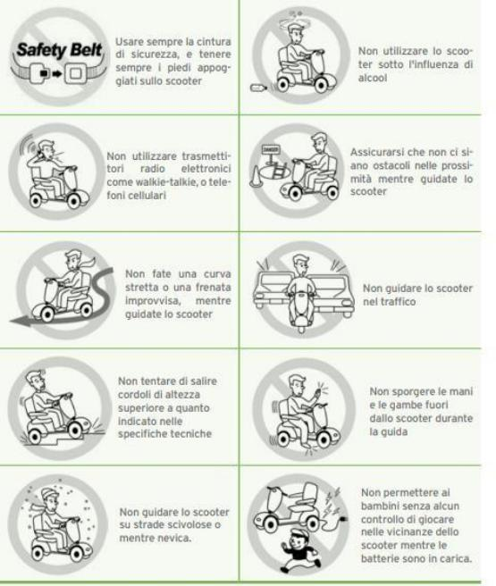
SECURITY

WARNINGS FOR USE
1.Do not use the scooter on public transit roads. Be aware that it can be difficult for traffic to see you when you are sitting on the scooter. Always use pedestrian paths. Follow all rules of pedestrian traffic. Wait until your path is free, and then proceed with extreme caution.

2.Before getting on or off the scooter always check that it is off and that the battery charger is disconnected to avoid injury to yourself or others.

- Always check that the drive wheels are in car mode before driving. Do not turn off the scooter when it is still moving, it would stop very abruptly.
4.Do not use this product or any other optional accessory available without first reading and fully understanding this manual. If nosanitarion can understand the warnings, the

Precautions or instructions, contact your dealer or health care professional before attempting to use the device, otherwise injury or damage may occur.

5.There are some situations, including some medical conditions, where the scooter user will need practice in using the scooter in the presence of a qualified assistant who may be a family member or a professional figure particularly prepared to assist the user in using the scooter duringvarious daily activities.6.Evitare di sollevare o spostare lo scooter da una qualsiasi delle sue parti rimovibili, inclusi i braccioli, il sedile o le carenature. Può causare lesioni personali e/o danni al dispositivo.
7. Avoid using the scooter beyond its limits, as described in this manual

8. Do not sit on the scooter while inside a moving vehicle.

9.Keep your hands away from the wheels (tires) while riding the scooter. Be aware that loose clothes can get caught in the wheels.

- Consult your doctor if you are taking drugs or if you have specific physical limitations. Some medications and limitations may affect the ability to use the scooter safely
11. Always check that the wheel release/lock lever is locked or unlocked.

12. Do not remove the rollover wheels if present on the scooter.

13.Contact with tools can cause electric shock; Do not connect an electric extension cord to the AC/DC converter or battery charger.

14.Although the scooter is able to overcome slopes at 25 ° try to avoid driving on routes with gradient greater than 15 ° and be very careful when cornering slope.

15. Do not climb a slope higher than the limit of the scooter.

16.Avoid getting off in reverse from steps, sidewalks or other obstacles. This can cause the scooter to fall/overturn.

17.Always reduce thelocality and maintain a stable center of gravity in tight curves. Do not use maximum power in tight corners.

- Using the scooter in the event of rain, snow, forest conditions and on icy or slippery surfaces can have a negative effect on the electrical system.
19.Never sit on the scooter when used with any type of elevator or

Lifting product. The scooter is not designed for this use. Any damage or injury resulting from improper use is not the responsibility of the manufacturer.

20. Do not touch the engine after driving. It's hot.

BEFORE EVERY USE

1. Check the correct inflation of the tyres, if any.

2.Check all electrical connections and make sure they are all well connected and not corroded.

3.Check all wiring connections and make sure they are fixed properly.

4. Check ifreni
WEIGHT LIMITATIONS

1.Check the maximum flow rate information in the technical specifications table of this manual or on the label on the device. The power of the scooter is evaluated according to the flow rate.

2.Respect the weight limits indicated for your scooter. Exceeding the maximum range cancels the warranty. The manufacturer cannot be held liable for injury or damage to property resulting from failure to comply with the weight capacity.

3.Do not carry passengers on the scooter, it can compromise the center of gravity and cause tipping or falling.

TECHNICAL SPECIFICATIONS

FEATURES:

Model: EV5

Frame: Steel

Front and rear brakes: disc brakes

Engine: 60v 1500w

Battery: 60V58AH LEAD GEL

Battery charging time: 6-8 hours

Charger voltage: 220v, 50/60 Hz

Noise: < 60Db(A)

Speed: 25 km/h with 3 levels

Autonomy: about 50 Km

Maximum slope at full load: 25%

Weight: Kg 315

Dimensions: 2305*1100*1605mm

SERIES OPTIONAL:

Swivel seat to facilitate entry and exit from the vehicle Cold/hot air ventilation system

Radio mp3/mp4

Panoramic roof opening

Remote control alarm

Central locking Electric windows

Rear camera

Handlebar with steering wheel or handlebar

Hill holder (uphill start assistant) Touchscreen display

OPERATION OF THE SCOOTER

Your scooter is easy to use. However, we recommend that you read the following instructions carefully to familiarize yourself with your new medical aid.

GENERAL FUNCTIONS MANUBRIUM MODEL
1. Make sure you have count the scooter key, press the Start-Stop button once.

The engine should start

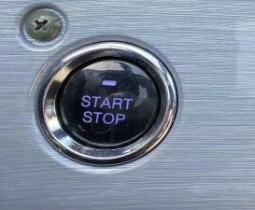

2.Start gear with the switch on the right of the handlebar. Move to position D to move forward and to position R to reverse. Engage N for neutral gear.

3. Turn the accelerator on the right knob to start the scooter. When reversing, an audible signal will be triggered.

4.Release the accelerator to allow the scooter to stop completely.

GENERAL FUNCTIONS WHEEL MODEL

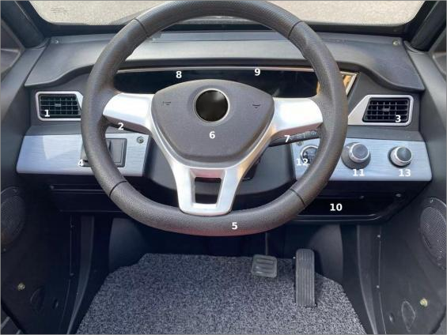
1. Ventilation system

2.Lights and direction indicators 3.Ventilation system

4.Ventilation switch

5.Steering wheel

6.Horn

7.Wipers 8.Display

9.Radio touchscreen 10.Storage compartment 11.Gear selector

12.Start-Stop button

13. Air conditioning switch (optional)

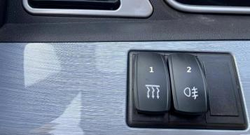
1.Ventilation system

2.Rear fog lamp

Starting the scooter

• Make sure the smart key is inside the scooter.
• Press the Start-Stop button once. The engine should
start.
Switching off the scooter
• Make sure the car is completely stationary and the brake is pressed.
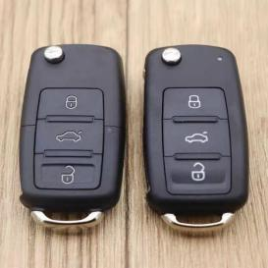
• Press the Start-Stop button once. The engine will shut down.
• Remove the smart key from the car.
Note: Make sure the smart key is
inside the car to turn it on and remove it
when the car is off. Also, if the car does not turn on when you press the Start-Stop button,
there may be a problem with the battery or
electrical system. In this case, please consult your trusted mechanic for a diagnosis and
repair.

3. Pedal brake
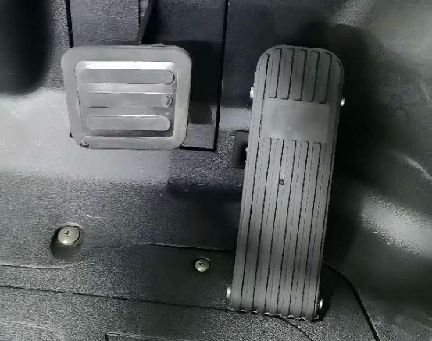
1.The brake pedal is located at the bottom of the car's driving area, on the left.
2.To brake the car, gradually press the brake pedal with your right foot.
3.The degree of pressure on the brake pedal determines the intensity of braking
of the car. When you need to brake quickly or firmly, press the brake pedal harder

4.In general, it is advisable to avoid abruptly braking or pressing the
brake pedal too strongly, as this can cause a car slip or an accident.
5.When the car stops completely, for example at a red light, it is
You can keep the brake pedal pressed to prevent the car from advancing.
6.When you start again, gradually release the brake pedal and simultaneously press the accelerator to restart the car.
Note: It is important to keep the brake pedal and brake system of the car in good condition, performing regular maintenance and replacing defective or worn parts as soon as possible

4. Drive gear: Forward / Stop / Reverse

1.If you need to move the car forward, place the knob on position D (Drive) and slowly advance by pressing the pedal of the accelerator.

2.To put the car in a dead spot, place the knob on the N position (Neutral).

3.If you need to go in reverse, place the knob on position R (Reverse) and slowly advance by pressing the accelerator pedal. When reversing, the car will emit a "DiDi" sound, and the reverse image (rear view camera) will be displayed in the Display.

Note: It is important to follow the instructions for driving gears carefully to avoid accidents and damage to the car. In case of doubt or

difficulty in using the gearbox, consult the car's user manual or consult a specialist mechanic.
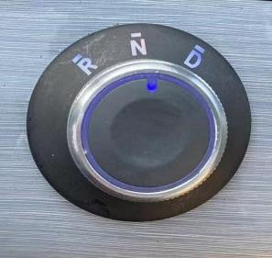


5. Wipers
1. Pressing this button activates the windscreen wipers


2. Pressing this button activates the window washer function

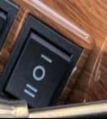
6. Ventilation system

1. Press the I or II button to turn on the ventilation system

2. Pressing the O button turns off the ventilation system

7. Direction indicators

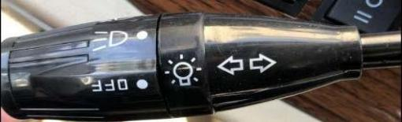
1.Raise the lever shown in the picture on the right to operate the right direction indicator

2.Lower the lever shown in the picture on the right to

Activate the left direction indicator

8. Delights function

1.To operate the lights, rotate the switch at the end of the lever shown on the right


2. Driving of the headlamps
Turn the switch at the end of the lever until the correct symbol shown on the right......

3. Driving of anabbaggliants
Turn the switch at the end of the lever to the correct symbol shown on the right.......

4. Lights off
Turn the switch at the end of the lever to the correct symbol shown on the right.......

DISPLAY
) .


CHARGING THE BATTERY
心
1.Manually adjust the correct input voltage (220V) .

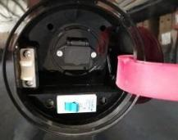


2.Open the flap on the back of the scooter to connect the power cord to the charger.
3. Connect the power cord to the electrical outlet. The flashing green LED indicates that there is power supply. 4.Charging will begin. During charging, the orange LED indicates that you are charging, when It turns green, the charge is complete.

LED INDICATIONS

1. Flash green lit

2.Flash orange: Pre charge

3. Orange: in charge

4.Flash orange and green: charge at 80%

5..Green: full charge

6.Red flash: defect

RESOLUTION OF PROBLEMS

1.If the green indicator is off:

•Check the AC input. If everything is working, the battery charge may be defective 2.If the green indicator continues to flash and does not indicate charging:

Check if the battery connector is connected correctly. Check if there is a short circuit on the output connection.

The battery charge may be defective if the battery connection works properly. 3.If the red light continues to flash:

• Check if the battery connection is reversed.

• Check if there is a short circuit on the output connection.

• Check if the ambient temperature is too low (0℃).

•The battery charge may be defective if the red light continues to flash again. 4.Charge indicator (orange) does not turn green:

•The battery may be defective, please stop charging and repair the battery. 5.If the charge indicator (orange) turns green (charge)

ATTATION
1.Before using the charger, read all instructions and warnings.
2.Use the charger in a well ventilated area.
3.To avoid the risk of injury, charge only lead-acid or gel batteries.

- Turn off the power after charging. Note: Use only the charger that was provided by the scooter supplier. The use of any othertype of charger can be dangerous and needs manufacturer approval.

Always charge the batteries in well ventilated environments.

The charger is intended for internal use only. Please protect it from moisture. For best performance, it is recommended to replace

both batteries at the same time if they are discharged.

If the scooter is not used for a long time, it is recommended to charge the batteries at least once a month to avoid deterioration

of the same.

Can we use a different charger? Please note that the battery chargers are selected

specially for special applications and matched to the type and size of the batteries required. In order to charge your scooter safely and efficiently, we recommend using the charger provided as original equipment.

Any method of charging batteries practiced individually is prohibited.

ETICHETTA FABBRICANTE

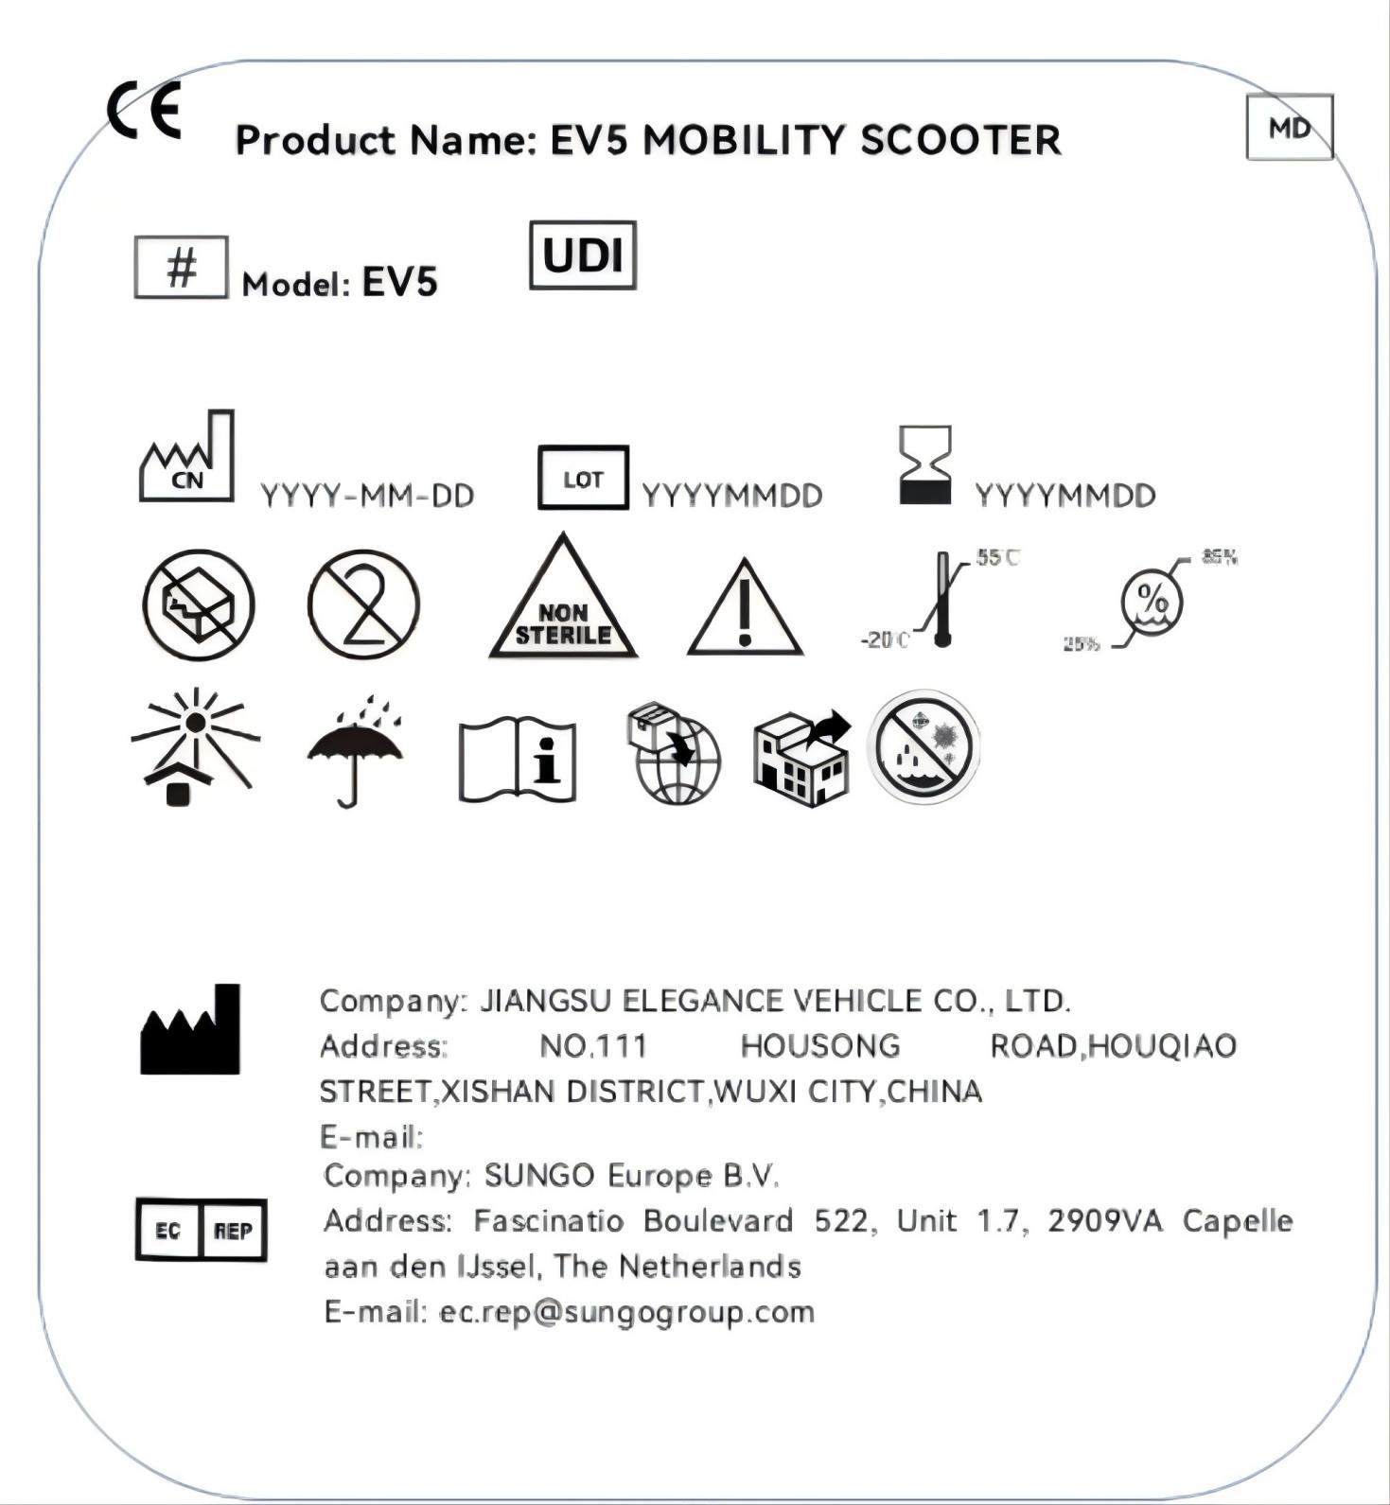

Jiangsu Elegance Vehicle Co., Ltd
NO. 111 HOUSONG ROAD,HOUQIAO STREET,XISHAN DISTRICT,WUXI CITY,CHINA

Dispositivo medico di classe I non sterile e senza funzioni di misura.
Registrato al ministerodella salute con numero: 2390975
Ultima revisione: Novembre 2023
Certificato CE (Regolamento CE 2017/745)

