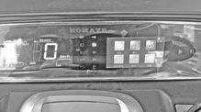
§1-1 Vehicle Instrument :
3
6
2
1
4
5
7

1.Voltmeter:Display the battery voltage
2.Speedometer:Show the vehicle driving speed
3.Left and right steering indicator lamp:The indicator flashes when the steering light is used
4.Coulombmeter:Display the battery power
5.Odometer:Show the current total mileage
6.Gear position indicator lamp:Gear switch turns to D\N\R, corresponding indicator light on
7.the instrument also has reversing image and display of receiver and release contents

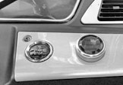
2
1

§1-2 Start switch :
Turn on:One-button start-stop button is in the pressed (bright) position to start the vehicle forward (D) or reverse (R), or stop (N)
Turn off：One-button start-stop button is in the press (not bright) position, the circuit is disconnected and the vehicle can not drive. However, if equipped with the central control function, the remote control can close the driving door lock.

1.One-button start-stop button 2.Position of the gear switch

Note: If the vehicle is equipped with a remote control, switch the vehicle power on and off using the remote control

§1-3 Left-hand switch assembly:
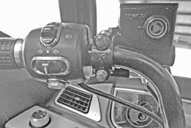
1
2
3



1.High and beam switch: Pull the switch to position, low beam on; dial the switch to position, high beam on

2.turn signal switch:In the middle position, the switch is off; the front and rear left turn lights are on and flashing when the switch is in ←; the front and rear right turn lights are on and flashing when the switch is in →
3.Horn switch:Press the horn switch button and the horn is on; release the horn switch button and the horn is off

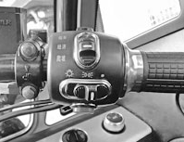
§1-4 Right-hand switch assembly:
2
1
3

1.Low-medium-high speed switch：The switch dials to the low speed position, turn the acceleration vehicle at low speed; the switch dials to the medium speed position, turn the vehicle to the medium speed; the switch to the high speed position, turn the vehicle at high speed
2.Light switch:Press the switch to the right position, when the light is off; press the switch to the middle position, the instrument and running lights on; press the switch to the marked position, the instrument and running lights on and the headlights on.
3.Wiper cleaning switch:Hold the switch, wiper washer works;release the switch and stop working immediately

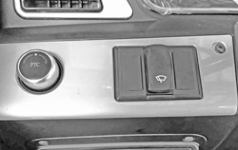
§1-5 Functional switch ：
2
1

1.Air-conditioning/heating switch:First rotate the air volume switch to the 123 position,press the button in the middle, then rotate the ac/ptc switch to the corresponding position, the instrument shows the ac/ptc indicator symbol bright, the air conditioning/warm air work
2.Wiper switch:Press the switch to the marked position, then the wiper motor works; press the switch to the other position, then the wiper motor does not work

§1-6 Main power supply switch ：
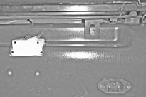

1

1.Main power supply switch:Located in the left side of the front seat, when the switch is in the on position, the vehicle is powered on, and then pressing the one-button start switch to start the vehicle; when the instrument shows the n indicating state, it cannot move forward and back.

The vehicle can choose two sets of batteries and can charge two batteries with chargers (use as required). When charging, follow the wiring to switch the position of the 2 switch switches to choose which set of batteries to charge.

§1-7 Door, windows and glass lifts:
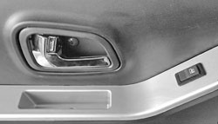
2
1
3

1.Glass lift switch:Press the front mark of the glass lift switch and the door glass rises; press the rear of the glass lift switch and the door glass drops
2.Door opening wrench:Pull the wrench to open the door lock and open the door
3.Door lock dial knob:Switch on the left side to open or lock the left and right door lock. Switch the right door to open or lock the right door

NOTE: Do not close the doors when the vehicle is locked to prevent damage to the parts

§1-8 Front and rear seats:
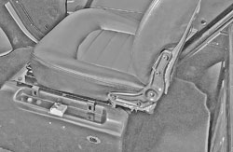
1

1.Front seat：Pull the dial bar on the slide up to move the seat back and back to the appropriate position; lowering the lever will lock automatically. If it cannot be locked, fine tune the seat back and back until the seat cushion is locked
2.Rear seat：The rear seat is fixed and can not be moved back and forth, and a battery set can be placed under the cover plate under the rear seat

§1-9 Door lock and open wrench:
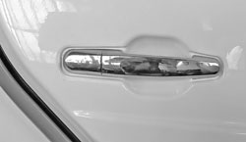
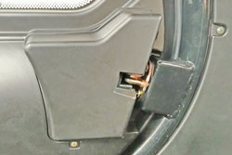
1
2

1.Door lock pull:Open the door by turning the lock core and pulling the handle on the door panel; turning the door in reverse; the central lock will work at the same time. Or use the remote control key
2.Internal lock:The interior lock body is mounted on the door interior panel and frame, open the plastic lock lid, to remove and adjust the lock body and adjust the status of the pull rod

§2-1 Inspection before driving：

Before starting driving every day, the whole vehicle should be routinely inspected to ensure good performance and safe driving results

Power-level display: Turn on the one-button start switch, watch the indicator position of the power meter, and charge first when below two grids or the voltage is less than 55v

Tyre:Front wheel pressure: 220kpa Rear wheel pressure: 250kpa

Accelerating system:Turn the acceleration rotor without turning on the power switch, without loose jam and free return

Brake system:Hold the brake bar and release for free return without jam
Other conditions such as seat position, mirror angle, door and door lock, whether the parts are loose, whether the horn and lamps are normal, and need to be checked before driving the vehicle every day.

§2-2 Driving Operation ：
1.turns on the power switch and one-button start switch, the instrument display should be normal, no alarm display
2. Put the gear switch in forward or backward gear as required, slowly turn the acceleration knob to reach the speed you want. Do not turn around to avoid adverse consequences
3. To reduce the speed, first close the acceleration knob, and use the front and rear brake knob

